1. Lesson Intro
2. Basic Media Query Intro

Media queries provide an easy logic for applying different styles depending on devices characteristics. Width, height, device pixel ratio.

Adding responsive styles is easy, simply include an additional stylesheet in your page with a media query.

<link rel=”stylesheet media=”screen and (min-width: 300px)” href=”patterns.css”>

1. Adding a Basic Media Query

<link rel=”stylesheet media=”screen and (min-width: 500px)” href=”over500.css”>

Stick with screen or print styles, print is used if you think someone will print your page.

1. Adding a basic media query 2

Imbedded media queries using the @media tag. Do not use import for media queries because performance matters.

@media screen and (min-width: 500px) {

body { color: #F79420; }

}

1. Next Step Media Queries

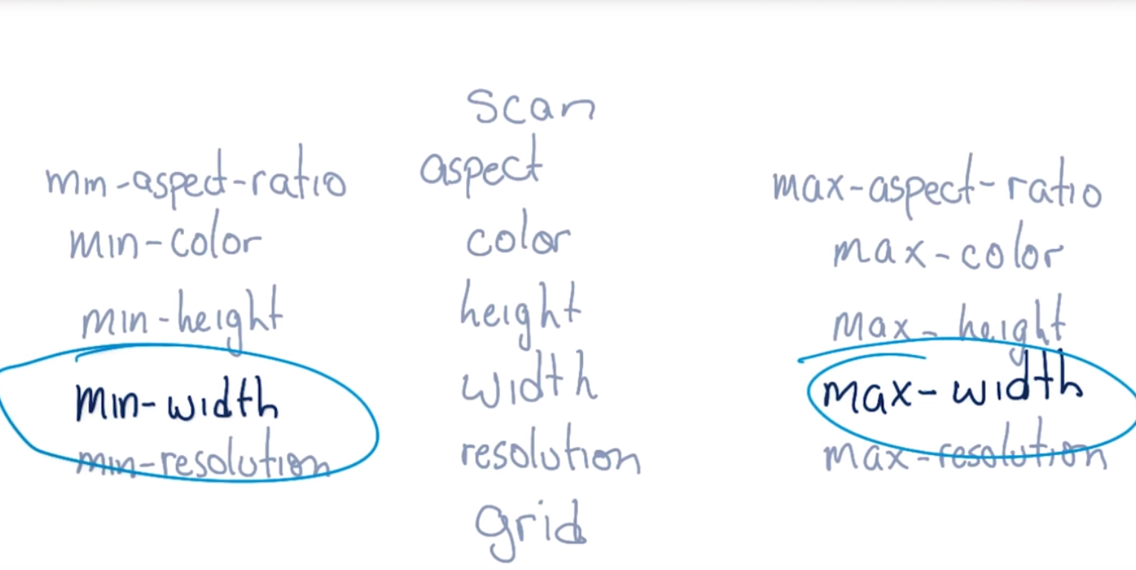

Max-width is applied when the characteristic is less than the value.

DO NOT use min-device-width or max-device-width, you want the window not the entire screen!

1. What Styles Are Applied?

Between 0 and 400 pixels, set the background color to red

Between 401 and 599 pixels, set the background color to green

600 pixels or wider, set the background color to blue

body {

background-color: green;

}

@media screen and (max-width: 400px) {

body { background-color: red; }

}

@media screen and (min-width: 600px) {

body { background-color: blue; }

}

1. Breakpoints

Use media queries as breakpoints to change the entire layout of the page. Could have one or several breakpoints.

1. Breakpoints Pt. II

Skinnyties.com

480 px = two columns

690 px = three columns

915 px = font size increased

1. Quiz: Number of Breakpoints
2. Picking Breakpoints

Where do I put my breakpoints?

Look at the content to find breakpoints.

1. Picking Breakpoints 2

Set a small viewport with chrome dev tools open.

1. Quiz: Pick a Breakpoint

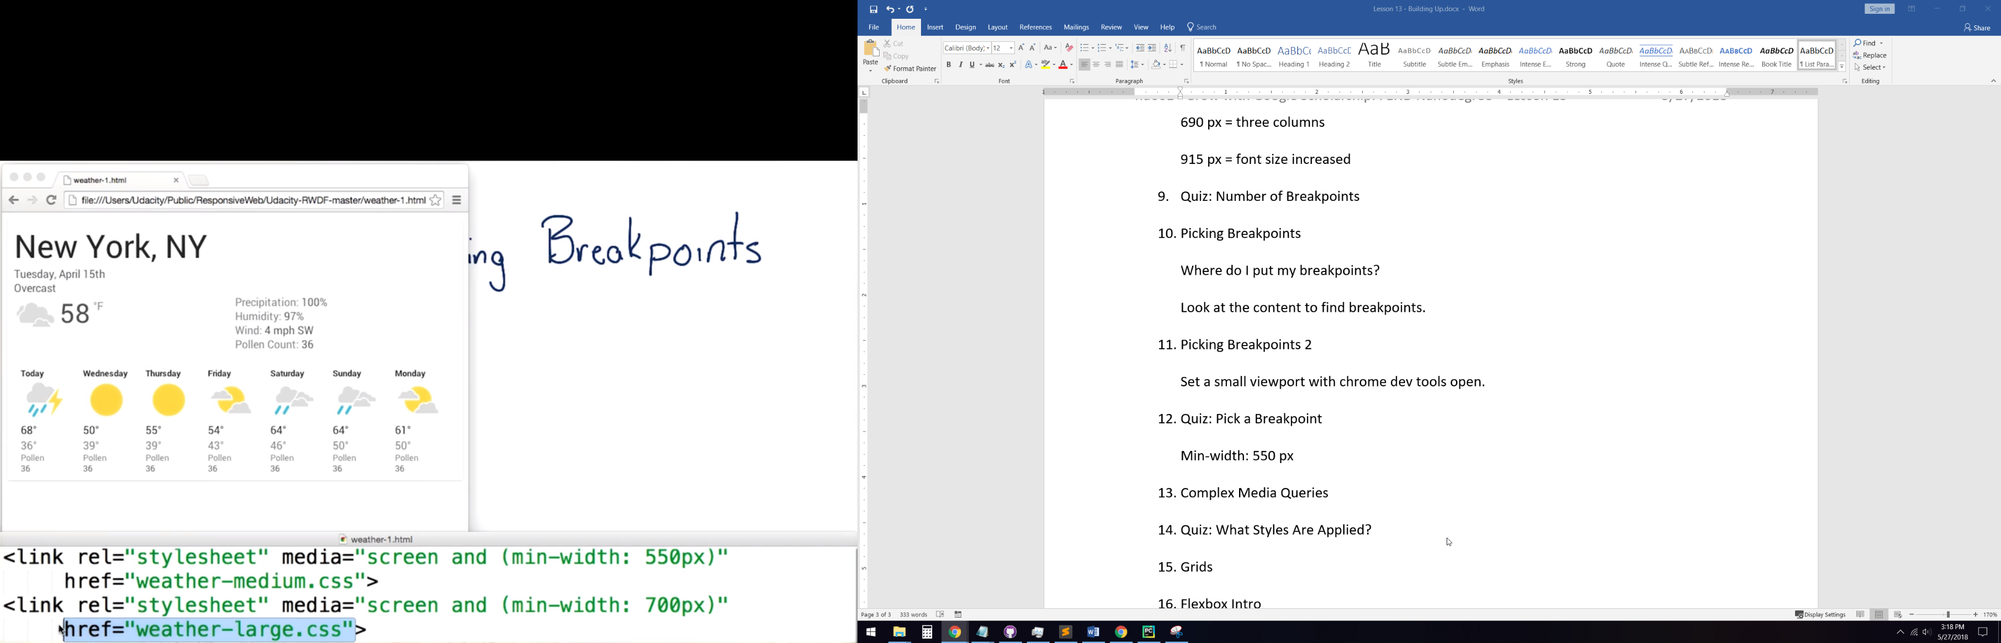

1. Complex Media Queries

Some cases you need to test more than just screen width.

1. Quiz: What Styles Are Applied?

@media screen and (max-width: 400px)

@media screen and (min-width: 301px) and (max-width: 600px)

@media screen and (min-width: 601px)

@media screen and (min-width: 961px)

1. Grids

Grid-fluid system lets columns wrap to the next line.

1. Flexbox Intro

Flexbox is one of the most powerful tools for organizing a layout.

1. Flexbox Container

Once display: flex; is added, elements are put next to each other in a row.

flex-wrap: wrap; only resizes when it really needs to.

1. Flex Item

.dark_blue { order: 4; } sets the order in which the dark blue element appears to 4 (starting at 1).

1. Deconstructing a Flexbox Layout

Using relative widths and ordering, you can move flex boxes around a lot.

1. Quiz: Deconstructing a Flexbox Layout
2. Responsive Design Outro

GLHF let’s go!